ABOUT US

Meritweigh Nigeria Limited was established in 2016 and is one of the fastest growing Supplier of Digital Truck Weighing Systems in Nigeria. As a team, we have been in the weighing business for the last 4 Years. Being a privately held company, we have the ability to change and adapt quickly to our customer's requirement of weighing products & solutions than our competition.

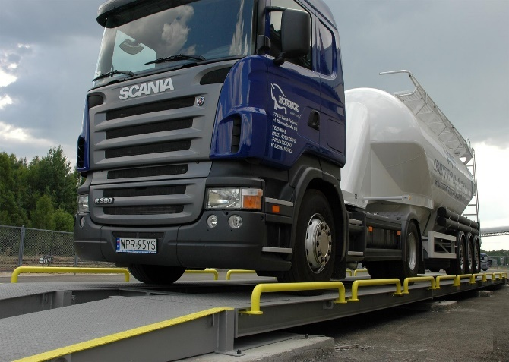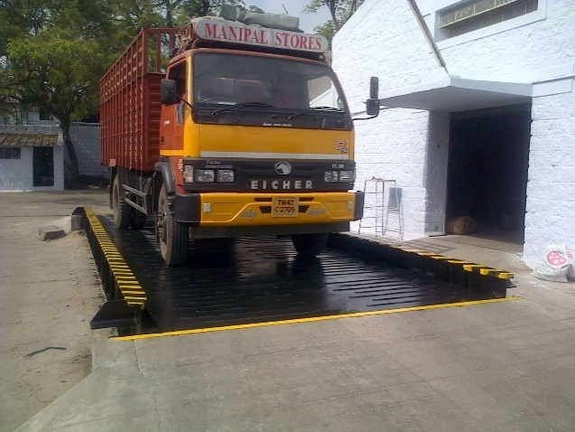

Meritweigh Nigeria Limited supplies a wide range of truck weighbridges of various capacitiesand other Digital weighing equipment and is committed to provide total solutions to digital Weighing equipment users.

With **more than 50 weighbridge installations in Nigeria** (number is growing steadily). MERITWEIGH has a reputation of being a prompt team right from quotations, through delivery and service of weighbridges.

Personalized service, convenience, confidence and quality are the few important factors our customers like in our organization and keep repeating the orders for their requirement of weighing products.

Our commitment is reflected in the relationship we have built with our team and our customers. Quality of our products are customer’s driven. We continuously strive to be better quality company in the hearts and minds of our customers with our creative problem solving and continuous improvement policies.

We serve our valued customers to their entire satisfaction with our quality products and prompt services as we firmly believe in CUSTOMER SATISFACTION.

We Supplies truck weighing systems of capacity ranging from 10T to 200T of platform size varying from 6 x 3 Meters to 18 x 3 Meters. Nevertheless we are too glad to manufacture any standard sizes and capacity of weighing systems in line with our company policy of “**meeting customers’ requirements by creative problem solving**”.

**Vision**

“To become the leading Weighbridge Construction firm in Nigeria and eventually the region, by consistently delivering Products that meet international standards.”

**Mission**

**To supply outstanding service and solutions through dedication and excellence.**

**Our Customers**

1. **Okay Alloy Nigeria Limited**
2. **Omega Feed mills**
3. **Sonnex Nigeria Limited**
4. **Crownmascot Agro Allied Limited**
5. **Amo byng Nigeria Limited.**

**OUR PRODUCTS**

* Weighbridge and Accessories
* [**Electronic Truck Weighbridges**](https://www.statweigh.co.in/weighbridge.html)
* [Pit Type Weighbridge](https://www.statweigh.co.in/weighbridge.html#pit-type-weigh-bridge)
* [Pit less Type Weighbridge](https://www.statweigh.co.in/weighbridge.html#pit-less-type-weigh-bridge)
* [Portable Weighbridge](https://www.statweigh.co.in/portable-weighbridge.html)
* [Weighbridge Load Cell](https://www.statweigh.co.in/loadcell.html)
* Weighbridge Indicators
* [Weighbridge Junction Box](https://www.statweigh.co.in/junctionbox.html)
* [Weighbridge External Display](https://www.statweigh.co.in/outdoordisplay.html)
* [Software for Weighbridge](https://www.statweigh.co.in/weighbridge-software.html)
* Platform Scale
* Floor Scale
* Crane Scale
* Portion Scales
* Laboratory Balance.
* Pallet Trucks. Etc.

**IMAGES**

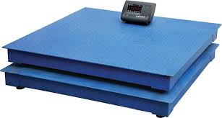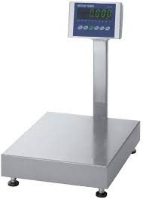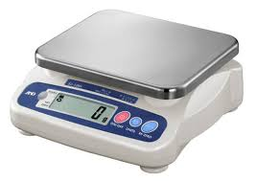

Floor Scale Platform Scale Portion Scale

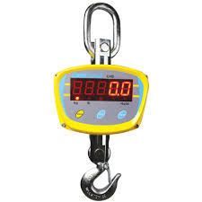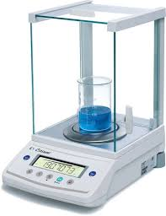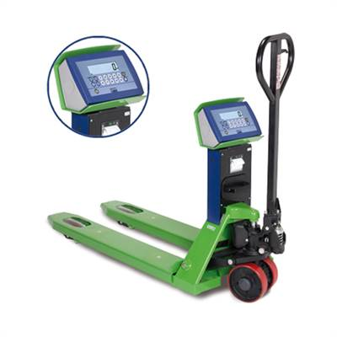

Hanging Scale Laboratory Scale Pallet Truck Scale

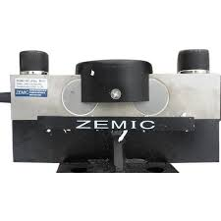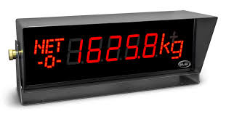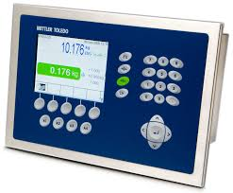

Load cell External Led Display Weighing Indicator

**OUR SERVICES**

**Installation and Repair**

We install all types of weighing equipment, verified to Nigeria standards and beyond.The ultimate aim for Meritweigh is complete customers’ satisfaction,we aim to fulfill all our obligations and more. Our helpful team is always available, 24/7, with instant response to assist.

We have an extensive network of highly skilled technicians ready to carry out all of our works throughout Nigeria, Africa and Internationally. We look forward to being of assistance.

**Project Report and Consultancy**

Meritweigh offers Weighbridge Project Report and Project Consultancy for setting up Weighbridge and Weighing System.

**Weighbridge Software**

Meritweigh can develop custom software application for weighbridges and weighing systems for your specific requirements.

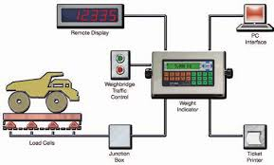

Weighing System Diagram

**Weighbridge Calibration**

We calibrate using certified test Weight according to industry tolerances and Issuance of Calibration Certificate.

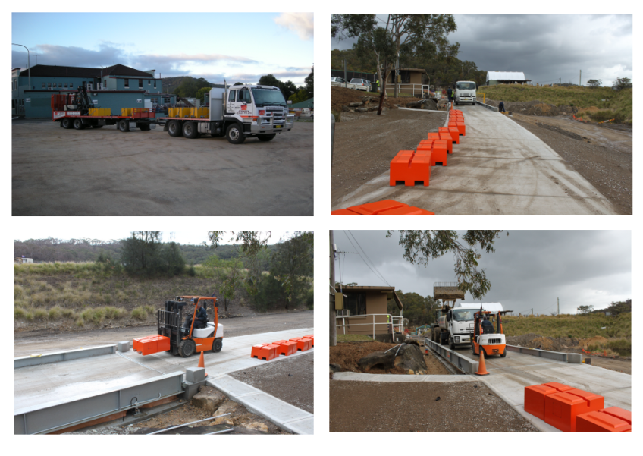

Weighbridge Calibration Diagram

**Weighbridge Maintenance**

1. **ANNUAL MAINTENANCE CONTRACTS (AMC)**

Weighbridge AMC.

Small scale AMC.

Automation AMC.

With Spares / Without Spares option available.

Bi-yearly Service options available.

With Stamping / Without Stamping options available.

1. **ON CALL PAID SERVICE**
2. **CONSULTANCY SERVICE**

**CONTACT**

**Head office**:*14, Alhaji Lukman Street, Ajao Estate.*

*Ikeja, Lagos State. Nigeria.*

**Branch office**: *8, Albarka Street, Off Morayo Hotel,*

*Agbowo Ibadan. Oyo State. Nigeria*

**Telephone**: *08024124339, 07038204005.*

**Email:**[info.meritweighing@gmail.com](mailto:info@meritweigh.com)